Group member: Edwin Viljoen 24823678

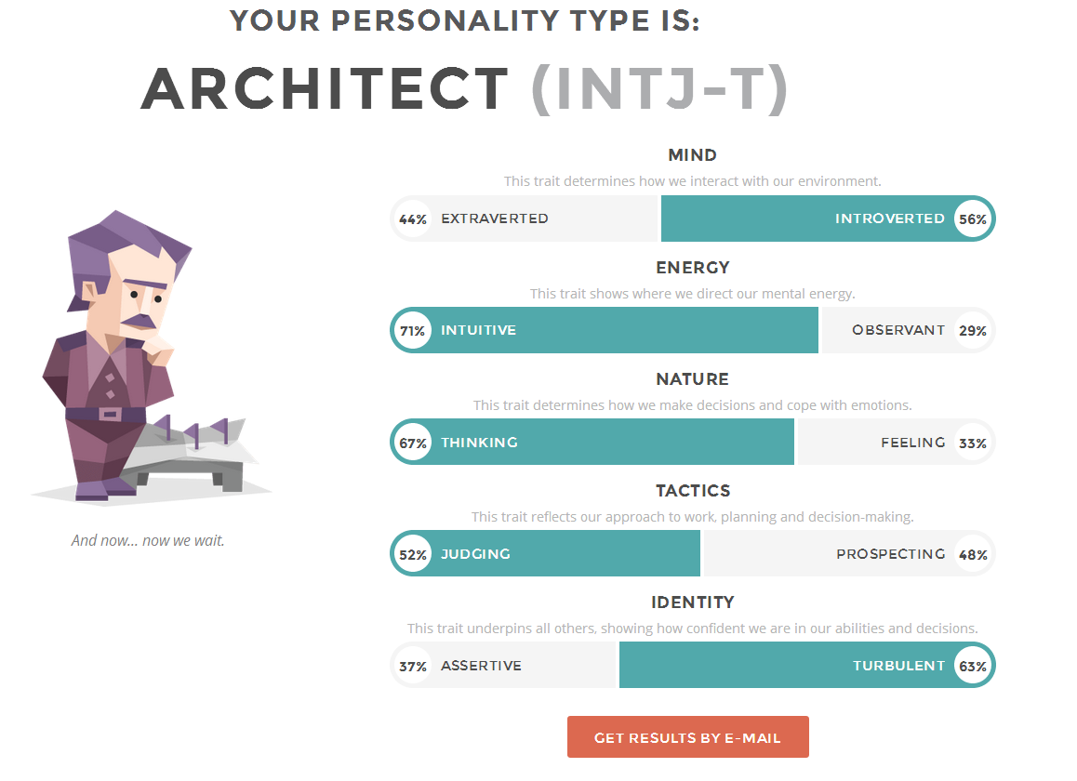

Described as the rarest, and one of the most intriguing personality types, architects are “lone wolfs”, who prefer to either work alone, or with people who can adhere to their exceptionally high work standards.

Architects like to plan thoroughly, and put a lot of thought into complex ideas and concepts, to solve difficult challenges. They are keen to take on any task that interests them, no matter how impossible it may seem, as they believe proper planning and intellect will always win!

Architects enjoy freedom, and do not like to be restricted to specific tasks and procedures, that will limit their creativity. They are highly independent and have extremely high expectations from managers, leaders, and colleagues, who will have to earn their respect with competence, high work standards, efficiency, and capability.

In the software development environment, the architect personality types will usually try to take on challenges by themselves, avoiding team efforts that will slow down, hinder, or complicate certain design elements.

Surprisingly, architects make natural team leaders, as they are meticulous planners and have a very lenient managing style. They value innovation and effectiveness above any other traits. They also promote a lot of freedom and flexibility in the workplace. They will gladly cast aside hierarchy, protocol, and even their own personal views, if given rational arguments as to why things must change.

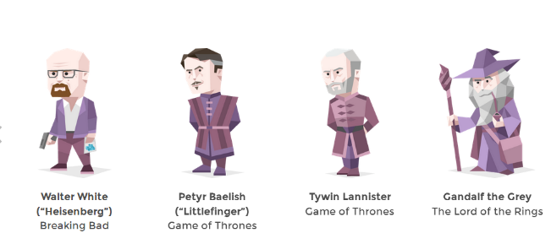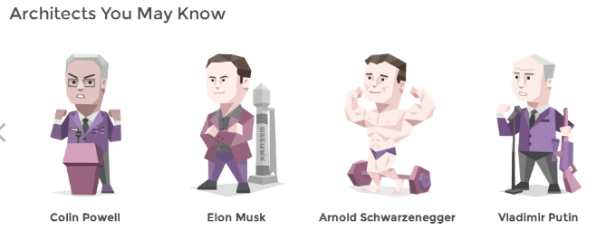Architects are proud to be effective and efficient and will get very frustrated with team members that do not display those qualities.